X (Feature) | y (Target)
60 | 72
64 | 73
63 | 78
66 | 79
75 | 82
Test point:
xtest​=62
Number of neighbors:
k=5

Step 1: Compute Euclidean Distance
Euclidean distance formula (1D case):
d= |x_test - x_i|
Training X | y | Distance
60 | 72 | (62-60)
64 | 73 | (62-64)
63 | 78 | (62-63)
66 | 79 | (62-66)
75 | 82 | (62-75)

Step 2: Select k Nearest Neighbors
Since k = 5, all points are selected.
Step 3:Normal KNN
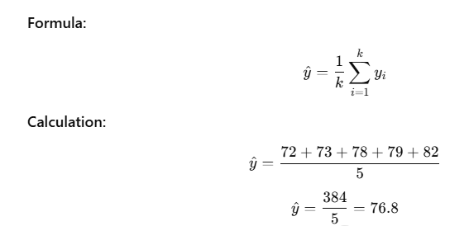
Weighted KNN Regression (Distance Weights)
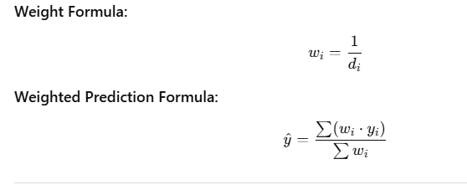
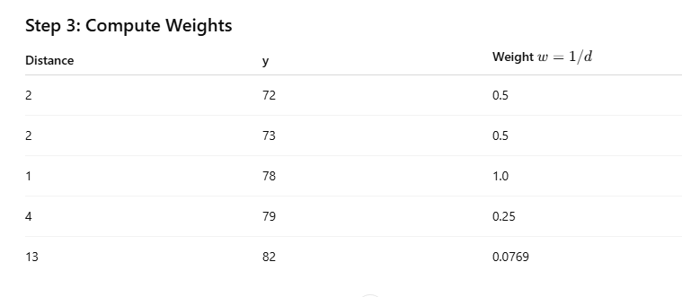

Step 4: Weighted Sum
